**BUSINESS INTELLIGENCE ASSIGNMENT**

**1**

**ENTRY OF JIO**

With the entry of jio in the market (2016), there is a huge growth in internet user base in India. India is now 2nd in the world in terms of internet users.

With the increase in internet users, online marketing and business got a boom and all thanks to jio.

But with contrast to it we can see that some business like of you tube/tik tok has growth rate much more then E-commerce or we can say the effect of jio is quite less in E-commerce sites.

THE QUESTION ARISES WHY? LET’S LOOK SOME POINTS TO PROVE THIS HYPOTHESIS

* **CONTENT**

If someone gives you an option to surf on the net watching random funny videos or to watch shirt and jeans for yourself, what will you choose? No doubt I can say people will prefer the first option. People in all tiers of cities consider surfing random you tube videos as better time pass then surfing E-commerce

* **DOMINATION**

If I have to say tell me a substitute of sites likes AMAZON/FLIPKART surely one can name a few ex – bewkoof.com, TATA CLIQ, SNAPDEAL , ALIBABA , EBAY etc. But what if I ask you to tell substitutions of you tube? Surely one need to Google it to find more such sites.

* **MONEY FACTOR AND DATA USAGE**

You tube/Tik tok provides entertainment free of cost, we not need to pay for it. Before the entry of jio in the market surfing such videos really need a lot of data to be used. But on other hands surfing on E-commerce sites uses less data and one have to spend money to buy something as entry of jio did not result in reduction of the prices.

**SOME GRAPHS TO PROVE THIS HYPOTHESIS**

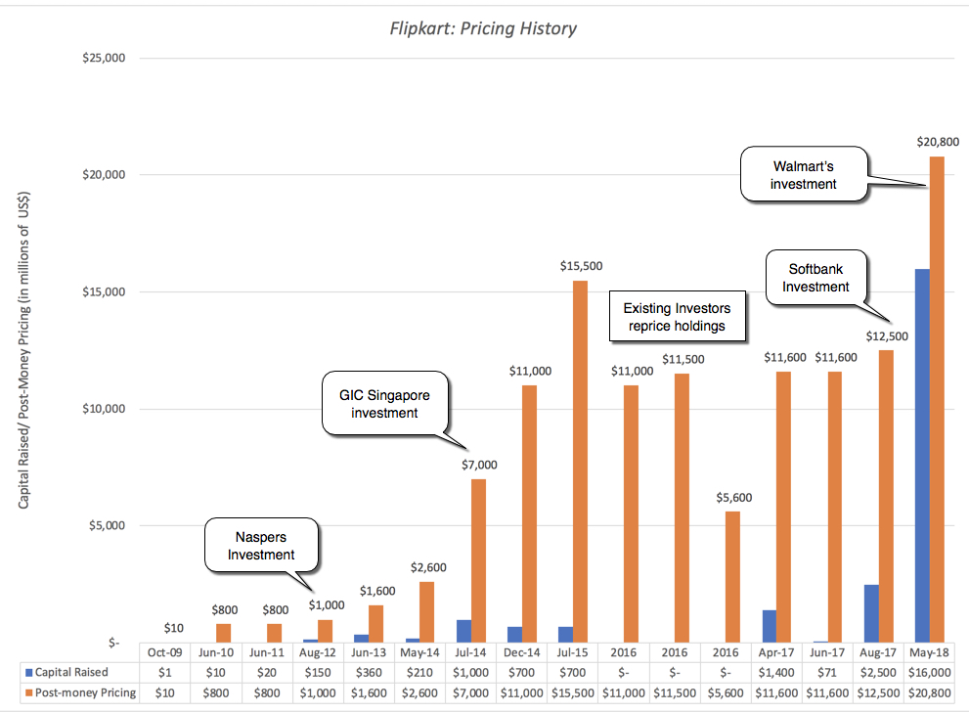

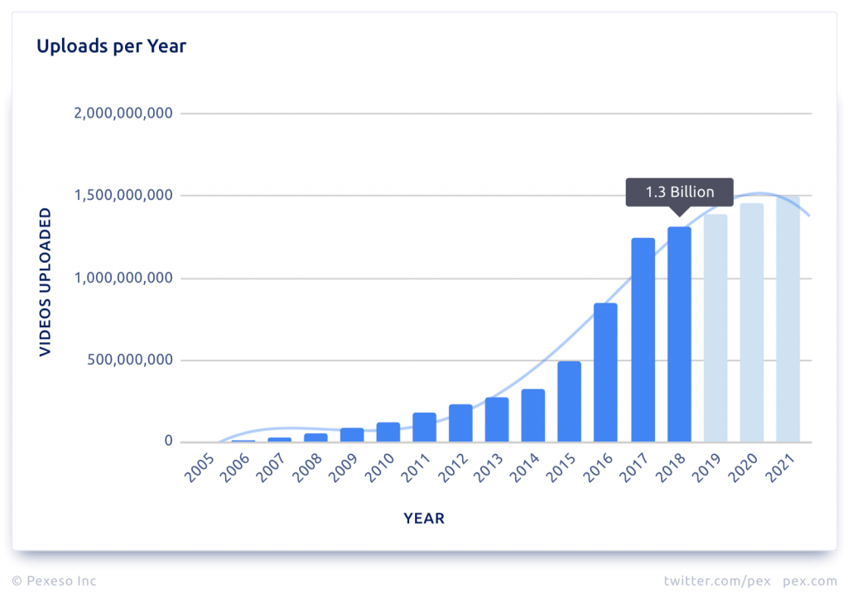

*BY THE GRAPH WE CAN EASILY SHOW THE GRAPH OF THE GROWTH POST JIO ERA (2016) AND PRE JIO ERA (AFTER 2016)*

**2**

**NEW ONBOARDING DESIGN AT NYMTRA**

NO DOUBT THAT THE ONBOARDING FLOW REVAMP IS DEFINETELY A SUCCESS. LETS US SEE WHY!

The effect of the flow revamp can be seen from the month of August as the revamp has taken place on 31st july.

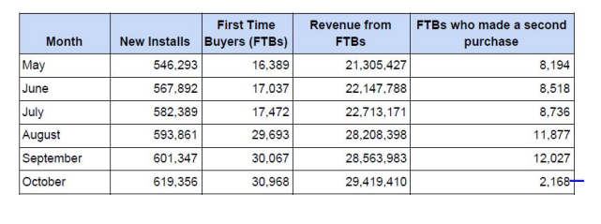

We can see that there is not a single consecutive month where every columns whether it may be *New Installs, FTB, Revenue from FTB* performance has not been increased after the implementation of the new flow revamp. Undoubtly this is a success.

**3**

**PERSONALISED RECOMMENDATIONS AT FILMISTAR**

1. Whenever I see any good movie my first reaction is always that why not bollywood makes such types of more movies. Not only just me whenever audience like any movies they search more such types of movies and when an app would bring such a feature of personalized recommendations audience will spend more and more time exploring the app.
2. The goals and metrics of this should be to tell the audience that there are hundreds of more movies available of your taste which you don’t know and would surely love to watch.
3. If this is a new feature on the app then while opening the app it must notify to the users that there is a new feature available on the app. Evaluation can be done by measuring the average time spend by the user in a particular span of time before and after the new feature. On a larger span of time we can also see the difference in the number of movies watched by an user.